Senior Cycle in St. Farnan’s PPS 2023-2024
Dear 3rd year/ Transition Year Students, Parents & Guardians,

In St. Farnan’s Post Primary School, we offer a number of pathways following the 3rd year of Junior Cycle. An explanation of the pathways has been given at the Transition Year/Fifth Year Information Evening but can also be found in the Senior Cycle Student Options Handbook on our school website.
In January 2023 you were given the opportunity to express interest in one of the programmes we offer in St. Farnan’s PPS. At this point we ask you to please complete the table below indicating your final decision of which preferred pathway that you wish your son/daughter to follow for the 2023-2024 academic year.

STUDENT NAME: _______________________________ Current 3rd/ TY class: __________________________
PARENT SIGNATURE: _____________________________________ Date: _______________________________
Please TICK the course that you wish your son/daughter to follow from August 2023:

Transition Year (4th year) 5th Year (Leaving Cert Year 1) Leaving Cert Applied
Year 1

- The Transition Year Programme will be explained in detail at the Information Evening meeting.

- Leaving Cert Applied (LCA) is split into four half-year sessions, with more emphasis on continuous assessment instead of the end of year exams. Students are awarded a Distinction, a Merit or a Pass. The Leaving Certificate Applied has a strong vocational dimension which equips students with skills for the world of work and life-long learning. Credits are also dependent on 90% attendance in LCA classes.

The following subjects are taken during the 2 years of LCA: Irish, Maths Applications, English & Communications, Intro to ICT, Vocational Preparation & Guidance, Work Experience, Social Education, Leisure & Recreation, Hotel & Catering, Visual Art, Engineering, Modern Foreign Language.

Students wishing to further their education after LCA can do so by progressing into Post Leaving Certificate (PLC) courses. These are one-year courses (two in some cases) in a very wide range of specialist areas. PLC courses are at level 5 on the National Framework of Qualifications (www.nfq.ie). Students may then proceed to college or university to undertake further study.

- The Established Leaving Certificate information and Options Subjects choice are on the reverse of this page and includes information on the Leaving Certificate Vocational Programme (LCVP).

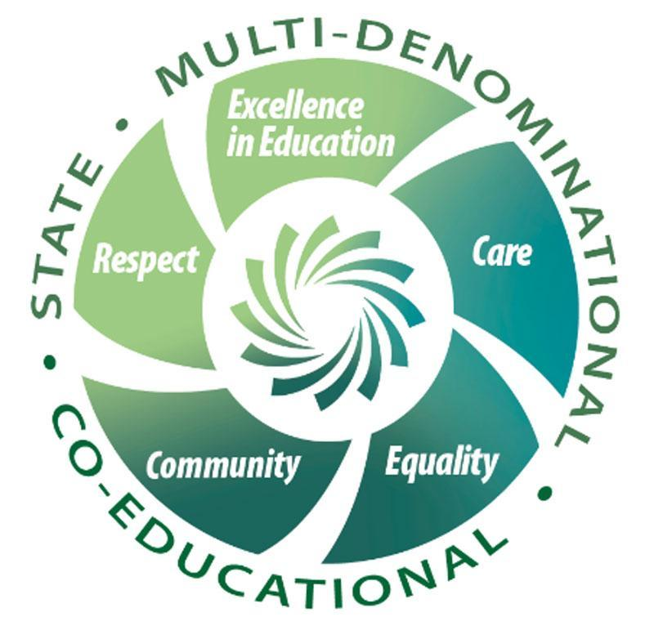
PLEASE TURN OVER PAGE AND COMPLETE
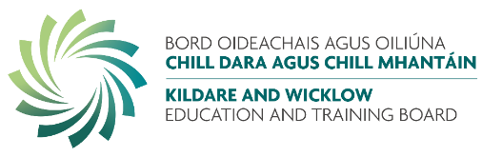

The Established Leaving Certificate examination subjects available to our students are: English, Irish and Maths (alongside non-exam subjects RSE, Tutorial, Careers/Guidance, Religion, PE etc.). Four other optional subjects must be taken by students sitting the Leaving Certificate Established.
There is also the availability to take the Leaving Certificate Vocational Programme (LCVP) - the programme consists of the normal 7 Leaving Certificate subjects, together with three compulsory link modules on enterprise education, preparation for work and work experience. Students wishing to study LCVP should tick the box labelled LCVP on the next page.

Please choose your top 6 choices by inserting the numbers 1 to 6 in the corresponding boxes to highlight your subject choices in order of preference. 1 being the subject that you most want to study etc.

Subject | Order of Preference  1-6 |  | Please Note:  It is important to note that all students may not receive their first four choices and all these options are subject to change depending on course uptake.  We will endeavour to get you as many first choice options as possible but this is not a guarantee. Also, please note that some subjects may clash based on the overall preference of the year group.  Information relating to course content, assessment procedures, links with other subject areas and third level/career options are available for each of the below subject areas in the Senior Cycle Student Options Handbook. This can be found on the school website www.stfarnans.ie under the tab labelled Parents and in the Student Options Subject section  Please ensure that you spend time to review each subject area and carefully make your decision. Under each subject area you will find the key staff to speak with regarding any queries about the subject.  Please return to Mr. Little on or before Wednesday 15th of March. Please note you can return by handing to Mr. Little or to the front office or by email to alittle@stfarnans.ie  Late returns may not get their preferred options.
Agricultural Science
Art
Biology
Business
Chemistry
Construction Studies
DCG (Design & Communication Graphics)
Engineering
French
Geography
History
Home Economics
Music
Physics
Spanish
Politics & Society
*** NEW SUBJECT FOR 23-24 ***

Physical Education (PE)
[Exam Subject]
*** NEW SUBJECT FOR 23-24 ***

LCVP |  |  | Please tick the box to the left if you are interested in pursuing LCVP (Link Modules)

In Senior cycle PE (THIS IS SEPARATE TO THE EXAM BASED OPTION PHYSICAL EDUCATION ABOVE) is offered as a double period versus study. In the space below please indicate whether PE would like to be taken or Study.
STUDY
PE

PLEASE MAKE SURE THAT YOU HAVE COMPLETED ALL SECTIONS OF THIS FORM BEFORE SUBMITTING
I HAVE:
- Ensured my name is on Page 1
- Indicated if I wish to study LC, LCA or TY
- I have numbered my option subject 1-6 based on preference
- I have ticked the box for LCVP if I wish to study it
- I have selected if I want to study PE or Study
THIS FORM IS DUE BACK TO MR. LITTLE BY WEDNESDAY 15TH OF MARCH 2023

